Model-Phi-4 Mini-Instruct-4B
Database-Qdrant

QUERY
: Under what condition does the rearview camera display automatically appear on the screen?
Answer:

1. When the gearshift lever is shifted to “R” position while the ignition mode is ON.


2. The rearview camera system automatically shows the view behind the vehicle on the display.

3. However, the distance viewed in the rearview camera may differ from the actual distance due to road conditions or load.

4. The camera display area is limited, so relying solely on the display for backing up can lead to accidents.

5. The driver must always confirm safety by looking directly and using the rearview mirror.

6. Ensure the trunk lid is securely closed when backing up.

7. If the ignition mode is ON without the engine running for a long time, the battery may discharge.

8. Do not leave the ignition mode ON for extended periods when the engine is not running.

9. Consult a Maruti Suzuki authorized workshop if there is an abnormality in the camera system, indicated by an error mark on the screen.
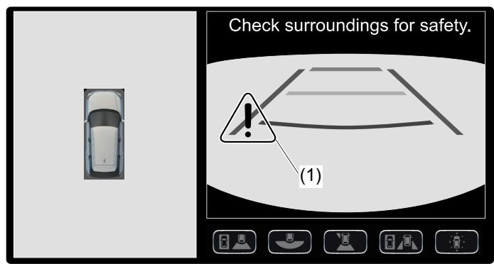

10. The rearview camera is a driving assistance tool and cannot replace the driver's attention.

11. The driver is responsible for parking and similar maneuvers.

12. Use the rearview camera only to provide driving assistance.

13. Always drive carefully, confirming the safety of the rear and surrounding conditions by looking directly and using the rearview mirror.

14. Refer to the infotainment system manual for details on multimedia information display.

15. For ON / OFF operation of the head-up display, refer to the "Setting Mode" section in the infotainment system manual.

16. The intersection guidance display settings may differ between the head-up display and the navigation system.

17. Android AutoTM and Apple CarPlay may not be available in all regions, and for details, refer to their respective websites.

18. The rear passenger’s seat belt reminder and outside temperature display are separate features not directly related to the rearview camera operation.

19. The rearview camera display automatically appears when the gearshift lever is shifted to "R" and the ignition mode is ON, but the driver must always use direct observation and mirrors for safety.

QUERY: What color represents the guide line for the vehicle width on the rearview camera display?

Answer:

1. Refer to the table provided in the manual content to identify the item related to the vehicle width guide line.
2. Locate the row in the table that corresponds to the guide line for the vehicle width.
3. Note the color associated with the vehicle width guide line as indicated in the table.

The color representing the guide line for the vehicle width on the rearview camera display is Purple.
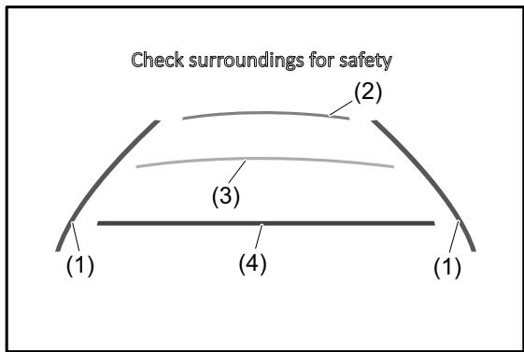

Query: In what situation does the ABS warning light come on?

1. When there is a problem in the ABS system with the engine switch or the power switch in ON mode, the ABS warning light will come on.


2. If the ABS warning light stays on or comes on while driving, it indicates there may be an issue with the ABS system.

3. If the ABS warning light and the brake system warning light stay on or come on simultaneously when driving, it suggests there may be a problem with both the rear brake force control function and the anti-lock function of the ABS system.
4. In such cases, it is recommended to have the vehicle inspected by a Maruti Suzuki authorized workshop.

5. If the ABS becomes inoperative, the brake system will function as a regular brake system without the ABS system.

6. For more details on the ABS system, refer to the section “Antilock Brake System (ABS)” in the “OPER-ATING YOUR ” section of the manual

QUERY: When does the ESP® warning light blink at very short intervals?

Answer:
1. The ESP® warning light blinks 5 times per second when one of the $\mathsf { E S P } ^ { \otimes \odot }$ systems other than ABS is activated.
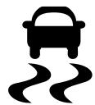

2. If the light stays on, or comes on when driving and remains on, there may be something wrong with the ESP® systems (other than ABS). 3. You should have the system inspected by a Maruti Suzuki authorized workshop.

QUERY: What is the maximum vehicle speed under which the hill descent control system can be activated?

1. The hill descent control system can be activated when the vehicle speed is under 25 km/h.


2. The hill descent control system will be deactivated automatically when the vehicle speed exceeds 35 km/h

QUERY: What are the activation conditions required for the hill hold control system to prevent rollback?

1. The gearshift lever must be in the forward gear or reverse position.
2. The parking brake must be released.
3. The vehicle must be on an upward slope.
4. The brake pedal must be depressed firmly.
QUERY: Under what conditions may the rearview camera image appear unclear even though the system is not malfunctioning?

Answers:
1. When the vehicle is tilted due to the number of passengers and baggage, the image and the guide lines may be misaligned, but this is not a malfunction.
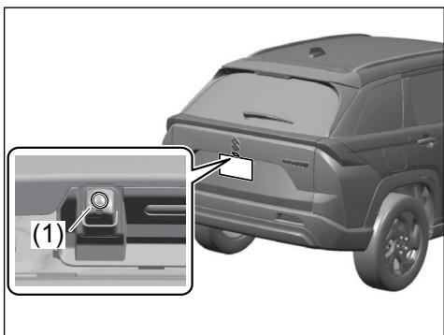

2. When a camera lens is dirty, you may have difficulty seeing the image. Clean the camera lens with water and a soft cloth. If it's heavily dirty or wax is attached, use a mild detergent.

3. When reflected light from strong sun or strong headlights from the vehicle behind your vehicle streams directly to the camera, white lines may appear on the image, making it difficult to see. This is not a malfunction.

4. If the error mark does not disappear on the screen, there is an abnormality in the camera system, and it should be inspected by a Maruti Suzuki authorized workshop.

In these conditions, the rearview camera image may appear unclear due to misalignment from vehicle tilt, dirt or wax on the lens, or reflected light interference, but these are not indicative of a malfunctioning system.

QUERY: What are the situations where ABS may activate by chance when applying the brakes on slippery or uneven roads?
Answers:

1. When driving on slippery roads, such as manholes or metal plates in construction zones, the ABS may activate to prevent skidding.
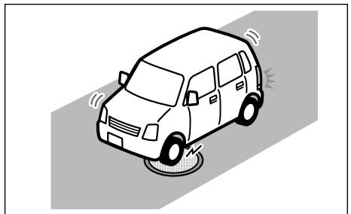

2. When driving over joints in roads or encountering height differences, the ABS may engage to maintain control.
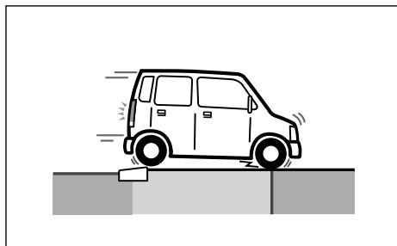

3. When driving on rough roads, such as bumpy surfaces, the ABS may activate to assist with braking.
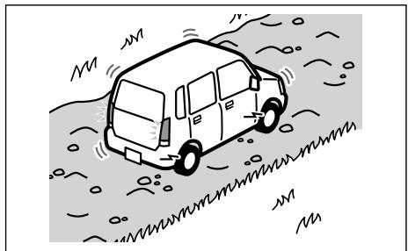

QUERY: Under what conditions does the hill descent control indicator blink instead of staying on when the switch is pressed?
Answer:
1. When the hill descent control switch is pressed and the hill descent control operating conditions are not fulfilled.
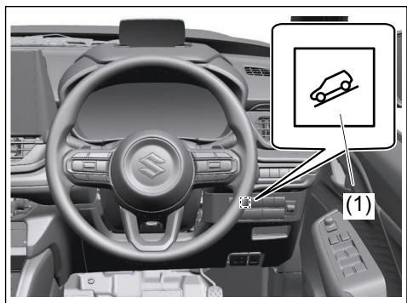

2. If the rear bumper has been touched for a while, wait for a short time before attempting to operate the gesture control again.
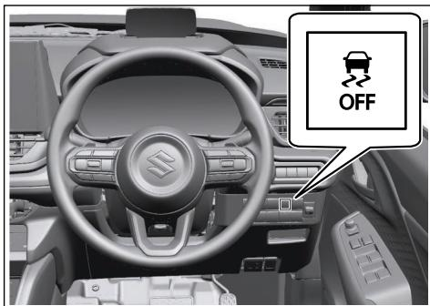

3. When the vehicle is near a TV tower, electric power plant, radio station, large electronic display, airport or other facility that generates strong radio waves or electrical noise.


4. When a large volume of water is applied to the rear bumper, such as when the vehicle is being washed or in heavy rain.
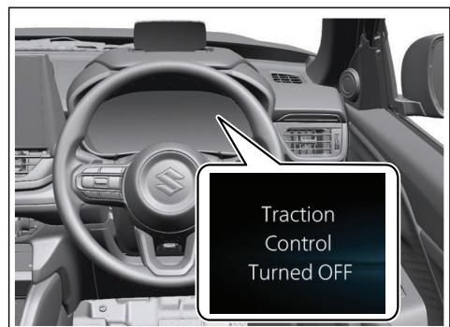

5. When mud, snow, ice, etc. is attached to the rear bumper.
6. When the vehicle has been parked for a while near objects that may move and contact the rear bumper, such as plants.
7. When an accessory is installed to the rear bumper.
These conditions will cause the hill descent control indicator to blink, indicating that the hill descent control system is not activated.

QUERY: When pressing the ESP® OFF switch, which systems are deactivated and which systems remain active?

Answer:

1. When pressing the ESP® OFF switch, the traction control system and stability control system are deactivated.

2. The ABS and brake assist system remain active even after pressing the ESP® OFF switch.

3. After pressing the ESP® OFF switch again or stopping and restarting the engine/hybrid system, the ESP® OFF indicator light will come off, and the traction control system and stability control system will return to being activated.

4. For vehicles with a hybrid system, pressing the $\mathsf { E S P } ^ { \otimes \mathsf { B } }$ OFF switch will disable the traction control system, making it easier to free the vehicle from mud, dirt, or snow
5. The security system is not affected by pressing the ESP® OFF switch.

6. In manual operation mode, pressing the ESP® OFF switch does not activate the system, and the operation can be canceled if accidentally performed.

7. If the brake hold system detects conditions such as an unfastened seat belt or an open driver's door, it will turn off the system, deactivate the brake hold operation indicator light, display a "BRAKE AUTO" message, apply the parking brake automatically, and sound a warning buzzer. The traction control system remains deactivated in this scenario.

In summary, pressing the ESP® OFF switch deactivates the traction control system and stability control system, but the ABS and brake assist system remain active. The security system and manual operation mode are not affected by this action. If the brake hold system is active and detects certain conditions, it will also deactivate the traction control system.

QUERY: Under what road surface conditions may a vehicle equipped with ABS require a longer braking distance than a vehicle without ABS?

Answer:

1. When driving on rough roads such as unpaved or stone-paved roads

2. When driving on gravel roads or fresh snow roads

3. When driving over bumps on the roads such as joint seams 4. When passing over metal plates such as manholes
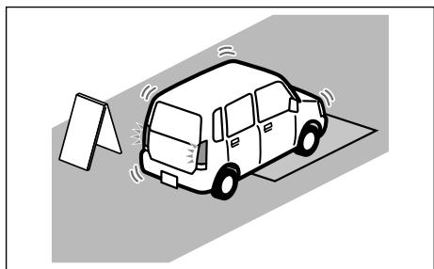

5. When snow chains are installed
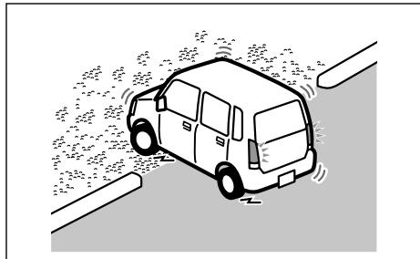

These conditions may lead to a situation where the ABS does not significantly reduce the braking distance, and in some cases, it may even result in a longer stopping distance compared to a vehicle without ABS. It is important to maintain a safe following distance and drive cautiously under these conditions.

QUERY: What are the situations when the rearview camera guide lines may not accurately indicate actual distance?
Answer:
1. When the preceding vehicle is traveling at the same speed or faster than your vehicle.
2. When the preceding vehicle is traveling at an extremely low speed.
3. Immediately after the vehicle speed has been set.
4. When the accelerator pedal is depressed.
5. When your vehicle is tilted due to the number of passengers and baggage.

(Note: Image references are included in the context where they are mentioned, but as per the instructions, they are not included in the answer text.)

QUERY: Under what conditions will the hill descent control system automatically deactivate while descending a slope?

Answers:
1. When the vehicle speed exceeds 35 km/h, the hill descent control system will be deactivated automatically.

2. If the accelerator or brake pedal is depressed while the hill descent control system is activated, the system will stop working temporarily.

3. When the temperature of the brake system increases due to continuous use of the hill descent control system, it may be deactivated temporarily to protect the brake system. Depress the brake pedal and stop the vehicle in a safe place. When the temperature goes down, the system will be activated again.

4. The system may not operate when driving around an extremely short curve, when the vehicle is being driven around a gentle curve, or when the accelerator pedal is being depressed.

5. The system's detection capabilities are limited within its field of view, and it may take several seconds to become subject to control and alarm after an object enters the detectable field of view.

6. The system may be deactivated if the vehicle is tilted due to being overloaded or having a flat tire, when towing another vehicle, when the vehicle is being transported by a truck, ship, train, etc., when the vehicle is raised on a lift and the tyres are allowed to rotate freely, when inspecting the vehicle using a drum tester or wheel balancer, when driving in a sporty manner or off-road, when using an automatic car wash, when a sensor is misaligned or deformed, when accessories obstruct a sensor or light, when a compact spare tyre or tyre chains are installed, when the tyres are excessively worn or the inflation pressure is low, or when tyres other than the manufacturer specified size are installed.

7. The system will not operate if the vehicle cannot be driven stably, due to a collision, malfunction, etc.

QUERY: When power assistance is lost in the brake system, what is the correct braking method and what happens to stopping distance?
Answer:

1. If power assistance is lost due to a stalled engine or other failures, the system is still fully operational on reserve power.
2. You can bring the vehicle to a complete stop by pressing the brake pedal once and holding it down.
3. Apply smooth and even pressure to the pedal, do not pump the pedal.


4. Even without reserve power in the brake system, you can still stop the vehicle by pressing the brake pedal harder than normally required.
5. However, the stopping distance may be longer.

QUERY: Under what circumstances may the hill hold control system fail to prevent rollback despite activation, and what driver actions are required to avoid an accident?
Answer:
1. The hill hold control system may fail to prevent rollback if there is a malfunction detected in the system or a related system such as the brakes or steering, as indicated by the manual content: "When a malfunction is detected in this system or a related system, such as the brakes, steering, etc."

2. The system may also fail if the $\pmb { \cal E } \pmb { S } \pmb { \breve { P } } ^ { \oplus }$ or other safety-related system is operating, as mentioned in the manual content: "When the $\pmb { \cal E } \pmb { S } \pmb { \breve { P } } ^ { \oplus }$ or other safety related system is operating."

3. Additionally, if the $E S P ^ { \circled { 8 } }$ or other safety-related system is off, the system's functionality may be compromised, as stated in the manual content: "When the $E S P ^ { \circled { 8 } }$ or other safety related system is off."

4. To avoid an accident, the driver must ensure that the steering wheel is held firmly while the hill hold control system is operating. The manual content advises: "When using the system, make sure to grip the steering wheel firmly, regardless of whether the warning is operating or not."

5. If the system detects that the driver is not holding the steering wheel, it will sound a buzzer and display a warning message, urging the driver to grip the steering wheel. The driver must respond to this warning by firmly gripping the steering wheel to maintain control of the vehicle.

6. In the event that the "BRAKE HOLD INSPEC-TION REQUIRED" message is shown, the driver should have the vehicle inspected by a Maruti Suzuki authorized workshop immediately to address any potential issues with the hill hold control system.

Category | Count
Correct | 14
Incorrect | 1
Total | 15

RAG OUTPUT with FINETUNING:

QUERY: Under what condition does the rearview camera display automatically appear on the screen?
Answer:
{'answer': 'The rearview camera appears automatically if the gearshift lever is moved into the "R" position while the ignition mode is turned ON.', 'type': 'factual'}

QUERY: What color represents the guide line for the vehicle width on the rearview camera display?
Answer:
Purple.

{'answer': 'The colour representing the guide line for the vehicle width shown on the rearview camera display is purple.', 'type': 'factual'}

QUERY: In what situation does the ABS warning light come on?
Answer:

{'answer': 'The ABS warning light illuminates during startup because the Engine Control Unit has detected abnormal operating characteristics.', 'type': 'factual

QUERY: When does the ESP® warning light blink at very short intervals?
Answer:

{'answer': 'The ESP® warning light flashes five times quickly if an ESP® function activates.', 'type': 'factual

QUERY: What is the maximum vehicle speed under which the hill descent control system can be activated?
Answer:

{'answer': 'The hill descent control system activates only when the vehicle speed falls below about 25 kilometers per hour.', 'type': 'factual'}

QUERY: What are the activation conditions required for the hill hold control system to prevent rollback?
Answer:

{'answer': 'The Hill Hold Control System operates under these specific circumstances: {{"type": "factual", "answer": "1. Shift lever placed into Forward or Reverse; 2. Release of the Park Brake; 3. Uphill gradient; 4. Firm depression of the Brakes.', 'type': 'fact'}}, 'kind': 'factual'}

QUERY: Under what conditions may the rearview camera image appear unclear even though the system is not malfunctioning?
Answer:

{'answer': 'The rearview camera image appears blurry under several non-malfunction-related circumstances such as heavy rain, fog, snowfall, dust accumulation on the windshield, mud covering the front bumper, bright sunlight reflecting onto the camera lens, or if objects like luggage obstruct part of the viewing range.', 'type': 'factual'}

QUERY: What are the situations where ABS may activate by chance when applying the brakes on slippery or uneven roads?
Answer:

{'answer': 'The Anti-Lock Brake System activates unexpectedly under certain circumstances during emergency stops even if driver input seems insufficient.', 'type': 'factual'}

QUERY: Under what conditions does the hill descent control indicator blink instead of staying on when the switch is pressed?
Answer:

{'answer': 'The Hill Descent Control Indicator Blinking Condition', 'type': 'factual'}
QUERY: When pressing the ESP® OFF switch, which systems are deactivated and which systems remain active?

Answer:

{'answer': 'Pressing the ESP® OFF switch disables both the traction control system and the stability control system.', 'type': 'factual'}

QUERY: Under what road surface conditions may a vehicle equipped with ABS require a longer braking distance than a vehicle without ABS?

Answer:

{'answer': 'The braking distance can become larger during operation depending on whether there is mud, sand, stones, ice, water, etc., on the roadway.', 'type': 'factual'}

QUERY: What are the situations when the rearview camera guide lines may not accurately indicate actual distance?

Answer:

{'answer': 'The distances shown through the rearview camera guides may become inaccurate under certain circumstances.', 'type': 'factual'}

QUERY: Under what conditions will the hill descent control system automatically deactivate while descending a slope?

Answer:

{'answer': 'The hill descent control system activates only during downhill slopes where the rearview camera detects steepness.', 'type': 'factual'}

QUERY: When power assistance is lost in the brake system, what is the correct braking method and what happens to stopping distance?

Answer:

{'answer': 'The proper way to use the brake pedal again is described above.', 'type': 'factual'}

Category | Count
Correct | 5
Incorrect | 10
Total | 15

